Q1: performs operations on a random 15-length vector

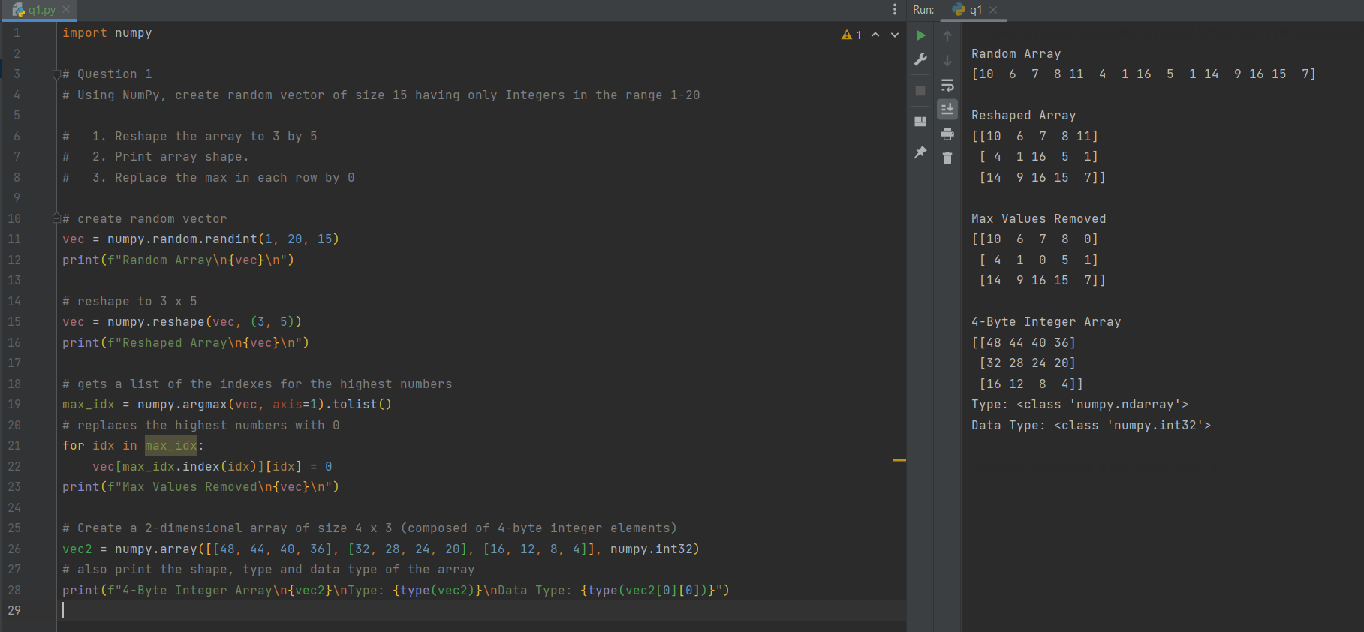

Q2: calculates eigenvalues and right eigenvectors of a given square array

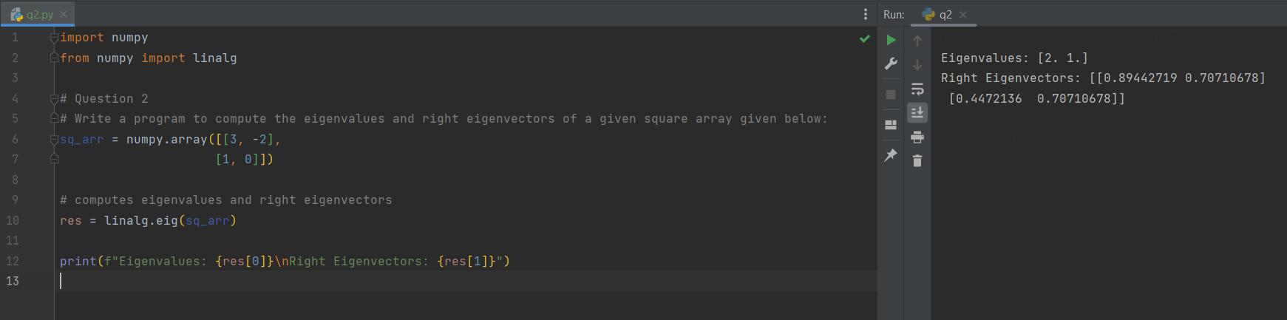

Q3: computes the sum of diagonals in a given array

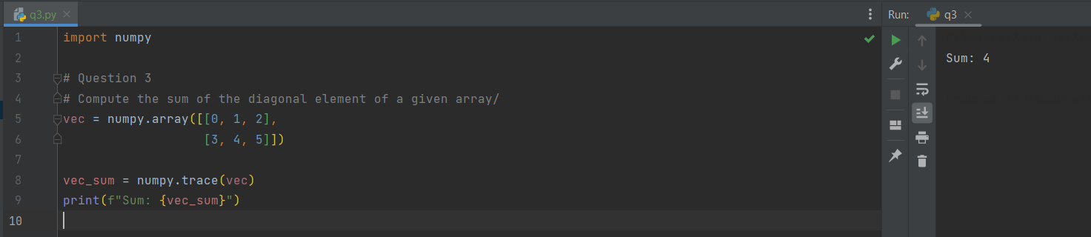

Q4: Changes the shape of a given array without changing its data

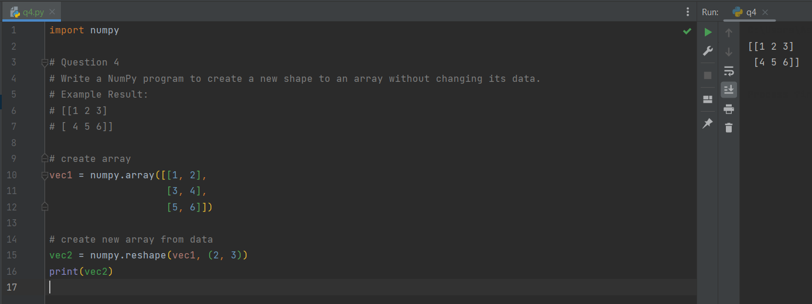

Q5: Creates a pie chart of the popularity of given programming languages

